

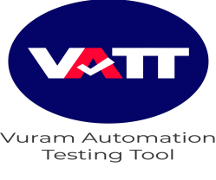

**Overview**

Vuram Automation Testing Tool(VATT) - developed using an intelligent hybrid framework that is designed to achieve 100% automation and perform end-to-end functional testing for the Appian applications. Using the framework is so simple that right from Quality Engineers to Business Users, just about anyone can use it.

**Configuration and Demo Guide - Release 1.0,**

1. Download the “VATT” package.

2. To import the package into your eclipse workspace. Please follow the below steps,

1



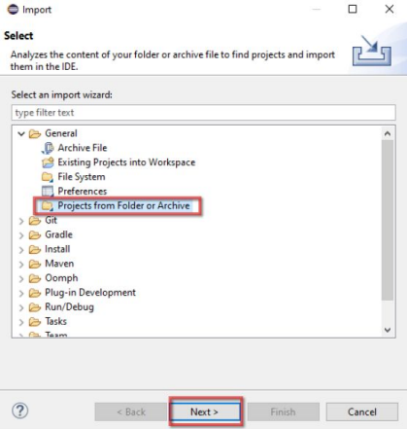2



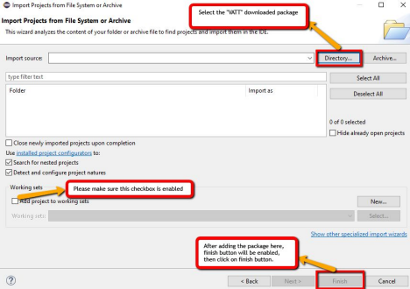

3. Install and configure the TestNG plugin with eclipse. If already installed, please follow the below steps,

Right click on the project>>Navigate to build path>>Add

libraries>>TestNG library>>Next>>Finish.

4. Update your project by following the below steps.

Right click on the project>>Maven>>Update project>>Select the current package from the dialogue box>>Click on update.

3



**Demo Guide - Release 1.0,**

**Prerequisite**,

Please make sure the chrome browser is installed in your system.

1. Please refer to the below snapshots to know more about the VATT folder structures and to use the framework in real time.

**Note:** Users can start writing their test scripts directly without doing separate scripting for creating a report, starting a driver and quitting a driver(By default, these actions are taken care of by the framework)

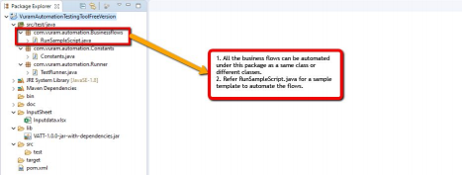**1(a)**

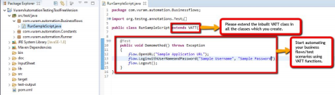**1.a.1**

4



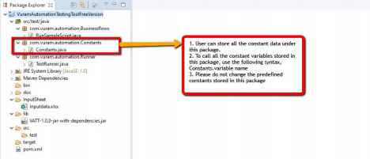**1(b)**

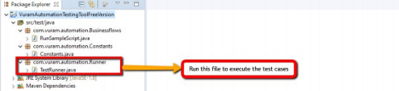**1(c)**

5



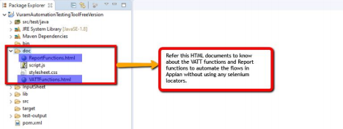 **1(d)**

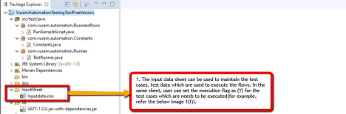 **1(e)**

** 1(f)**

6



 **1.(g)**

2. To run multiple business classes in sequence as a part of a single test case, add the required classes in a single cell as shown in the below image,

**2(a)** Adding multiple classes into the excel sheet

3. After the test run is completed in order to view the run report please refresh the package and view the run report under the Report folder.

Please write to automation@vuram.com in case of any concerns. 7